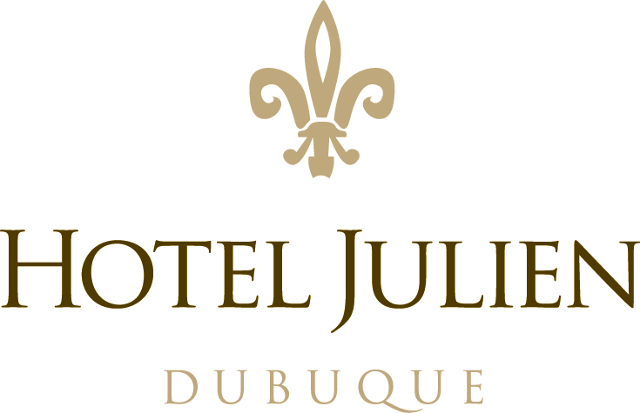

JOB POSTING ---
Banquet Manager

Hotel Julien Dubuque is hiring a Banquet Manager. Our Banquet Manager oversees the execution of meetings, banquets, galas, and weddings. Candidates must have previous years of banquet operations and/or banquet management. Knowledge in banquet invoicing, scheduling, and payroll important.
Candidates should be available to work day and evening shifts, weekdays and weekends.
This position will fulfill some of the following responsibilities..

- Knowledge of HJD Standards programs and products.
- Knowledge of proper serving techniques
- Familiar with all the daily BEO’s
- Be aware of and familiar with all VIPs at the property.
- Familiar with all groups with reservations for the outlets and their special requirements, if any.
- Be familiar with all the departments of the property, their functions and policies.
- Acquire and maintain knowledge of the property services/facilities and major attractions in the area.
- Assume any additional responsibilities as assigned by the Assistant Manager or the Food & Beverage Director.
- Aid bartenders with Micros functions
- Involvement in the Training program
- Supervise servers and bartenders during banquet functions
- Maintain a positive attitude at all times

This will be a full-time position, commencing immediately.

If you are interested in this position, submit your resume to Dwight Hopfauf at
gm@hoteljuliendubuque.com

